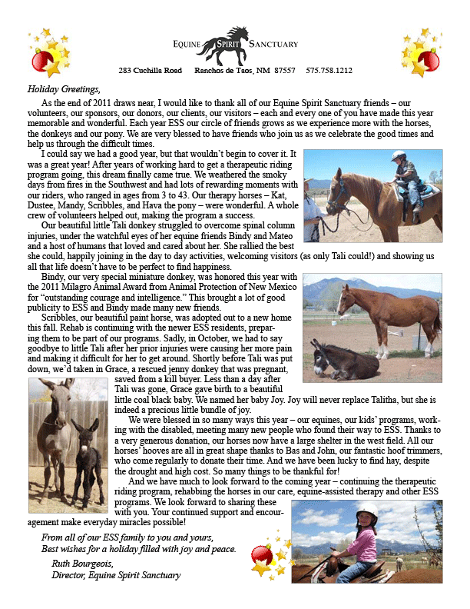
2011 Holiday Letter

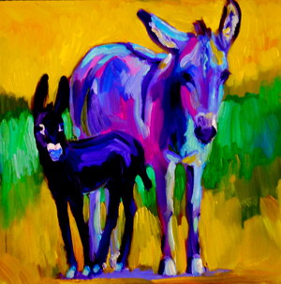

Grace and Joy, painting by Barbara Meikle

