*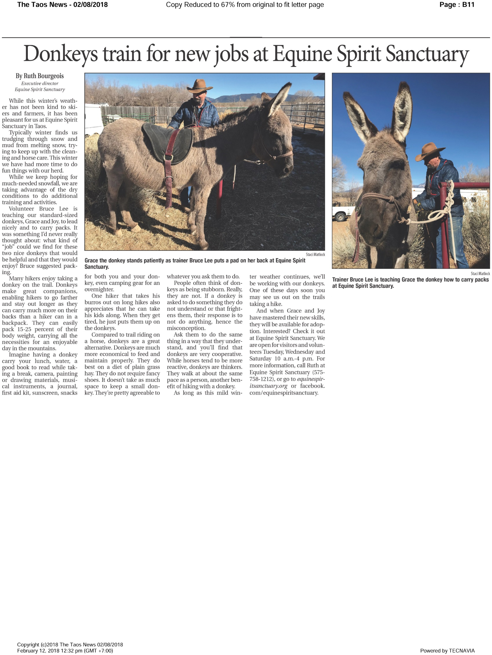The Taos News*, February 8, 2018